Database Normalization and Design Techniques
One of the most important factors in dynamic web page development is database definition. If your tables are not set up properly, it can cause you a lot of headaches down the road when you have to perform miraculous SQL calls in your PHP code in order to extract the data you want. By understanding data relationships and the normalization of data, you will be better prepared to begin developing your application in PHP.
Whether you work with mySQL or Oracle, you should know the methods of normalizing the table schema in your relational database system. They can help make your PHP code easier to understand, easier to expand upon, and in some cases, actually speed up your application.
Basically, the Rules of Normalization are enforced by eliminating redundancy and inconsistent dependency in your table designs. I will explain what that means by examining the five progressive steps to normalization you should be aware of in order to create a functional and efficient database. I'll also detail the types of relationships your data structure can utilize.
Let's say we want to create a table of user information, and we want to store each users' Name, Company, Company Address, and some personal bookmarks, or urls. You might start by defining a table structure like this:
Zero Form
users
name | company | company_address | url1 | url2
Joe | ABC | 1 Work Lane | abc.com | xyz.com
Jill | XYZ | 1 Job Street | abc.com | xyz.com

We would say this table is in Zero Form because none of our rules of normalization have been applied yet. Notice the url1 and url2 fields -- what do we do when our application needs to ask for a third url? Do you want to keep adding columns to your table and hard-coding that form input field into your PHP code? Obviously not, you would want to create a functional system that could grow with new development requirements. Let's look at the rules for the First Normal Form, and then apply them to this table.
First Normal Form
1. Eliminate repeating groups in individual tables.
2. Create a separate table for each set of related data.
3. Identify each set of related data with a primary key.
Notice how we're breaking that first rule by repeating the url1 and url2 fields? And what about Rule Three, primary keys? Rule Three basically means we want to put some form of unique, auto-incrementing integer value into every one of our records. Otherwise, what would happen if we had two users named Joe and we wanted to tell them apart? When we apply the rules of the First Normal Form we come up with the following table:

users
userId | name | company | company_address | url
1 | Joe | ABC | 1 Work Lane | abc.com
1 | Joe | ABC | 1 Work Lane | xyz.com
2 | Jill | XYZ | 1 Job Street | abc.com
2 | Jill | XYZ | 1 Job Street | xyz.com

Now our table is said to be in the First Normal Form. We've solved the problem of url field limitation, but look at the headache we've now caused ourselves. Every time we input a new record into the users table, we've got to duplicate all that company and user name data. Not only will our database grow much larger than we'd ever want it to, but we could easily begin corrupting our data by misspelling some of that redundant information. Let's apply the rules of Second Normal Form
Second Normal Form
1. Create separate tables for sets of values that apply to multiple records.
2. Relate these tables with a foreign key.
We break the url values into a separate table so we can add more in the future without having to duplicate data. We'll also want to use our primary key value to relate these fields:
users
userId | name | company | company_address
1 | Joe | ABC | 1 Work Lane
2 | Jill | XYZ | 1 Job Street

urls
urlId | relUserId | url
1 | 1 | abc.com
2 | 1 | xyz.com
3 | 2 | abc.com
4 | 2 | xyz.com

Ok, we've created separate tables and the primary key in the users table, userId, is now related to the foreign key in the urls table, relUserId. We're in much better shape. But what happens when we want to add another employee of company ABC? Or 200 employees? Now we've got company names and addresses duplicating themselves all over the place, a situation just rife for introducing errors into our data. So we'll want to look at applying the Third Normal Form:
Third Normal Form
1. Eliminate fields that do not depend on the key.
Our Company Name and Address have nothing to do with the User Id, so they should have their own Company Id:
users
userId | name | relCompId
1 | Joe | 1
2 | Jill | 2

companies
compId | company | company_address
1 | ABC | 1 Work Lane
2 | XYZ | 1 Job Street

urls
urlId | relUserId | url
1 | 1 | abc.com
2 | 1 | xyz.com
3 | 2 | abc.com
4 | 2 | xyz.com

Now we've got the primary key compId in the companies table related to the foreign key in the users table called relCompId, and we can add 200 users while still only inserting the name "ABC" once. Our users and urls tables can grow as large as they want without unnecessary duplication or corruption of data. Most developers will say the Third Normal Form is far enough, and our data schema could easily handle the load of an entire enterprise, and in most cases they would be correct.
But look at our url fields - do you notice the duplication of data? This is prefectly acceptable if we are not pre-defining these fields. If the HTML input page which our users are filling out to input this data allows a free-form text input there's nothing we can do about this, and it's just a coincedence that Joe and Jill both input the same bookmarks. But what if it's a drop-down menu which we know only allows those two urls, or maybe 20 or even more. We can take our database schema to the next level, the Fourth Form, one which many developers overlook because it depends on a very specific type of relationship, the many-to-many relationship, which we have not yet encountered in our application.
Data Relationships
Before we define the Fourth Normal Form, let's look at the three basic data relationships: one-to-one, one-to-many, and many-to-many. Look at the users table in the First Normal Form example above. For a moment let's imagine we put the url fields in a separate table, and every time we input one record into the users table we would input one row into the urls table. We would then have a one-to-one relationship: each row in the users table would have exactly one corresponding row in the urls table. For the purposes of our application this would neither be useful nor normalized.
Now look at the tables in the Second Normal Form example. Our tables allow one user to have many urls associated with his user record. This is a one-to-many relationship, the most common type, and until we reached the dilemma presented in the Third Normal Form, the only kind we needed.
The many-to-many relationship, however, is slightly more complex. Notice in our Third Normal Form example we have one user related to many urls. As mentioned, we want to change that structure to allow many users to be related to many urls, and thus we want a many-to-many relationship. Let's take a look at what that would do to our table structure before we discuss it:
users
userId | name | relCompId
1 | Joe | 1
2 | Jill | 2

companies
compId | company | company_address
1 | ABC | 1 Work Lane
2 | XYZ | 1 Job Street

urls
urlId | url
1 | abc.com
2 | xyz.com

url_relations
relationId | relatedUrlId | relatedUserId
1 | 1 | 1
2 | 1 | 2
3 | 2 | 1
4 | 2 | 2

In order to decrease the duplication of data (and in the process bring ourselves to the Fourth Form of Normalization), we've created a table full of nothing but primary and foriegn keysin url_relations. We've been able to remove the duplicate entries in the urls table by creating the url_relations table. We can now accurately express the relationship that both Joe and Jill are related to each one of , and both of, the urls. So let's see exactly what the Fourth Form Of Normalization entails:
Fourth Normal Form
1. In a many-to-many relationship, independent entities can not be stored in the same table.
Since it only applies to the many-to-many relationship, most developers can rightfully ignore this rule. But it does come in handy in certain situations, such as this one. We've successfully streamlined our urls table to remove duplicate entries and moved the relationships into their own table.
Just to give you a practical example, now we can select all of Joe's urls by performing the following SQL call:
SELECT name, url FROM users, urls, url_relations WHERE url_relations.relatedUserId = 1 AND users.userId = 1 AND urls.urlId = url_relations.relatedUrlId
And if we wanted to loop through everybody's User and Url information, we'd do something like this:
SELECT name, url FROM users, urls, url_relations WHERE users.userId = url_relations.relatedUserId AND urls.urlId = url_relations.relatedUrlId
Fifth Normal Form
There is one more form of normalization which is sometimes applied, but it is indeed very esoteric and is in most cases probably not required to get the most functionality out of your data structure or application. It's tenet suggests:
1. The original table must be reconstructed from the tables into which it has been broken down.
The benefit of applying this rule ensures you have not created any extraneous columns in your tables, and that all of the table structures you have created are only as large as they need to be. It's good practice to apply this rule, but unless you're dealing with a very large data schema you probably won't need it.
I hope you have found this article useful, and are able to begin applying these rules of normalization to all of your database projects. And in case you're wondering where all of this came from, the first three rules of normalization were outlined by Dr. E.F. Codd in his 1972 paper, "Further Normalization of the Data Base Relational Model". Other rules have since been theorized by later Set Theory and Relational Algebra mathematicians.
--Barry
5 Rules of Data Normalization

1. Eliminate Repeating Groups - Make a separate table for each set of related attributes, and give each table a primary key.
2. Eliminate Redundant Data - If an attribute depends on only part of a multi-valued key, remove it to a separate table.
3. Eliminate Columns Not Dependent On Key - If attributes do not contribute to a description of the key, remove them to a separate table.
4. Isolate Independent Multiple Relationships - No table may contain two or more 1:n or n:m relationships that are not directly related.
5. Isolate Semantically Related Multiple Relationships - There may be practical constrains on information that justify separating logically related many-to-many relationships.

1. Eliminate Repeating Groups
In the original member list, each member name is followed by any databases that the member has experience with. Some might know many, and others might not know any. To answer the question, "Who knows DB2?" we need to perform an awkward scan of the list looking for references to DB2. This is inefficient and an extremely untidy way to store information.
Moving the known databases into a seperate table helps a lot. Separating the repeating groups of databases from the member information results in first normal form. The MemberID in the database table matches the primary key in the member table, providing a foreign key for relating the two tables with a join operation. Now we can answer the question by looking in the database table for "DB2" and getting the list of members.
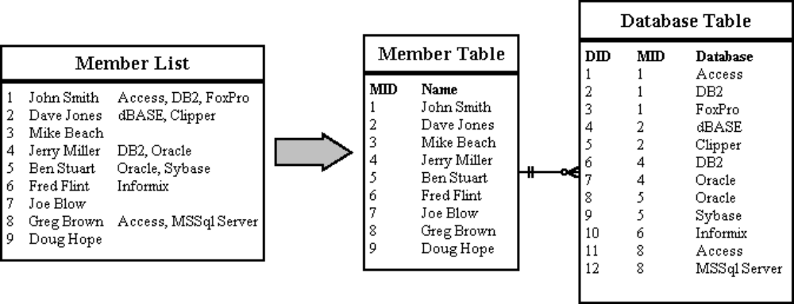

2. Eliminate Redundant Data
In the Database Table, the primary key is made up of the MemberID and the DatabaseID. This makes sense for the "Where Learned" and "Skill Level" attributes, since they will be different for every member/database combination. But the database name depends only on the DatabaseID. The same database name will appear redundantly every time its associated ID appears in the Database Table.
Suppose you want to reclassify a database - give it a different DatabaseID. The change has to be made for every member that lists that database! If you miss some, you'll have several members with the same database under different IDs. This is an update anomaly.
Or suppose the last member listing a particular database leaves the group. His records will be removed from the system, and the database will not be stored anywhere! This is a delete anomaly. To avoid these problems, we need second normal form.
To achieve this, separate the attributes depending on both parts of the key from those depending only on the DatabaseID. This results in two tables: "Database" which gives the name for each DatabaseID, and "MemberDatabase" which lists the databases for each member.
Now we can reclassify a database in a single operation: look up the DatabaseID in the "Database" table and change its name. The result will instantly be available throughout the application.
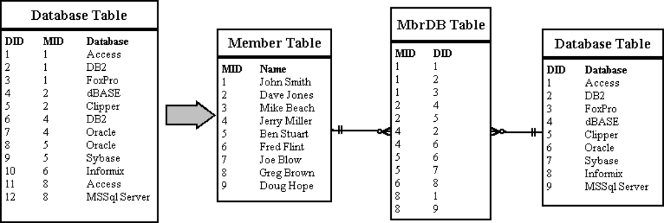

3. Eliminate Columns Not Dependent On Key
The Member table satisfies first normal form - it contains no repeating groups. It satisfies second normal form - since it doesn't have a multivalued key. But the key is MemberID, and the company name and location describe only a company, not a member. To achieve third normal form, they must be moved into a separate table. Since they describe a company, CompanyCode becomes the key of the new "Company" table.
The motivation for this is the same for second normal form: we want to avoid update and delete anomalies. For example, suppose no members from the IBM were currently stored in the database. With the previous design, there would be no record of its existence, even though 20 past members were from IBM!
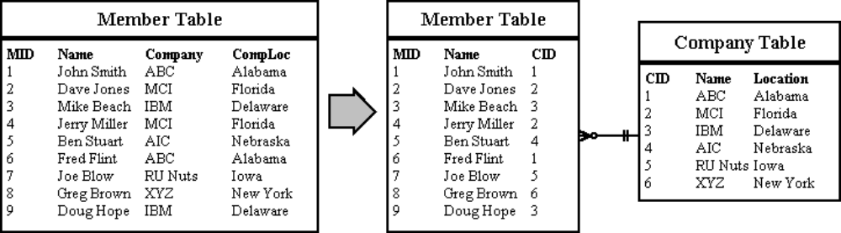

4. Isolate Independent Multiple Relationships
This applies only to designs that include one-to-many and many-to-many relationships. An example of one-to-many is that one company can employ many members. An example of a many-to-many relationship is that a member can know many databases and several members might know the same database.
Suppose we want to add a new attribute to the MemberDatabase table called "Attire". This way we can look for members that not only know DB2, but also typically wear a suit and tie. Fourth normal form dictates against this (using the MemberDatabase table, not wearing suits and ties). The two attributes do not share a meaningful relationship. A member may know a certain database, and he/she might just wear a wet suit. This doesn't mean he/she can do both at the same time (unless you have a water-proof computer terminal). How will you represent this if you store both attributes in the same table?
(Graphic under construction)

5. Isolate Semantically Related Multiple Relationships
Usually, related attributes belong together. For example, if we really wanted to record which databases each member works on wearing which kinds of clothes, we would want to keep the attire attribute in the MemberDatabase table. But there are times when special characteristics of the data make it more efficient to separate even logically related attributes.
Imagine that our system will record which jobs are available in each company, and which schools typically supply candidates to those companies. This suggests a CompanySchoolJob table which satisfies fourth normal form. As long as any company can use any candidates from any school, this works fine.
Now suppose a law is passed to prevent exclusive arangements: a company accepting candidates must accept them from all schools it deals with. In other words, if IBM is hiring DBAs and wants to maintain a relationship with MIT, it must accept DBAs from MIT.
The need for fifth normal form becomes clear when we consider inserts and deletes. Suppose a company decides to create 3 new jobs types: HTML DBA, Java Programmer and Underwater DB2 DBA. Suppose further that it already deals with three schools that can supply candidates for those positions. This will require nine new rows in the database, one for each school/job combination.
Breaking up the table reduces the number of inserts to six. Here are the tables neccessary for fifth normal form, shown with the six newly inserted rows in bold type. If an application involves significant update activity, fifth normal form can mean important savings. Note that these combination tables develop naturally out of entity-relationship analysis.
(Graphic under construction)

